Chaos.exe

An excellent and readable introduction to mathematical chaos is the book Chaos: Making a New Science by James Gleick.

This program illustrates one aspect of the mathematical theory called chaos theory.

This is about the mathematical equation

y_{n+1} = ɑ y_{n} (1 – y_{n})

where ɑ is a constant in the range [0,4]. The equation is to be used as an iteration, where y_{n} ∈ [0,1]. For example, if ɑ is the number 2.25, then

y_{n+1} = 2.25 y_{n} (1 – y_{n})

Starting with y₁ = 0.4, we get y₂ = 0.54, y₃ = 0.559, etc. The y values converge on 0.5555 (after an infinite number of steps) which is in fact a fixed point of the equation, i.e., plug in y_{n} = 0.5555 and get y_{n+1} = 0.5555. The convergent value depends on ɑ and is 0 if ɑ ≤ 1 and is positive if ɑ ∈ (1,3]. The first green line superimposed on the screen shot below shows the one value for ɑ = 2.25, namely 0.5555.

If ɑ > 3, all bets are off and there is no single convergent. Take ɑ = 3.2. After many iterations it settles down to two alternating values: 0.512 and 0.800. As ɑ changes so do these two convergents. The second green line in the screen shot below crosses the red graph at these two values for ɑ = 3.2.

When ɑ passes 3.45 we get not two values but four values that the equation cycles through. (The third green line on the graph.) Each of the two branches of the graph bifurcate at exactly the same value of ɑ. As ɑ increases past 3.5443 there is another bifurcation of the graph and we get eight values that we cycle through.

At some point we get an infinite number of y values, i.e., chaotic behavior.

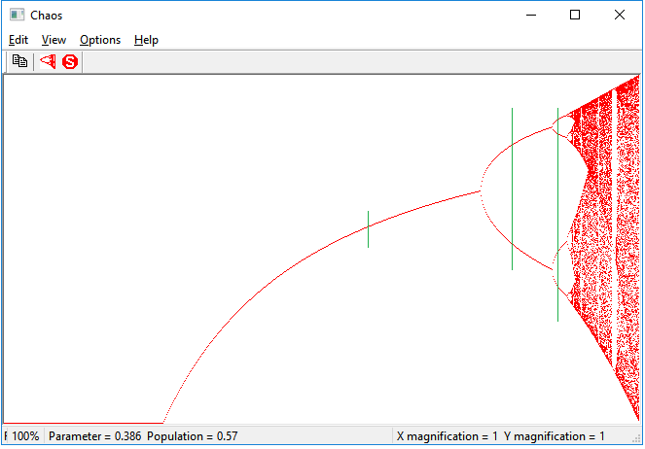

But in the realm of chaos there is some order, for as ɑ passes 3.8285 we descend from an infinite number of y values to only three y values. This is the “thick” vertical white strip near the right edge of the graph. Then the bifurcations set in and we get 6 values, 12 values, etc.
Zooming in (see below) will show you surprising structure to the graph.

You can zoom in by holding down the left mouse button, moving the mouse, and releasing the button when you have defined the zoom rectangle. For example, zooming in on the vertical white strip is done with the following zoom rectangle.

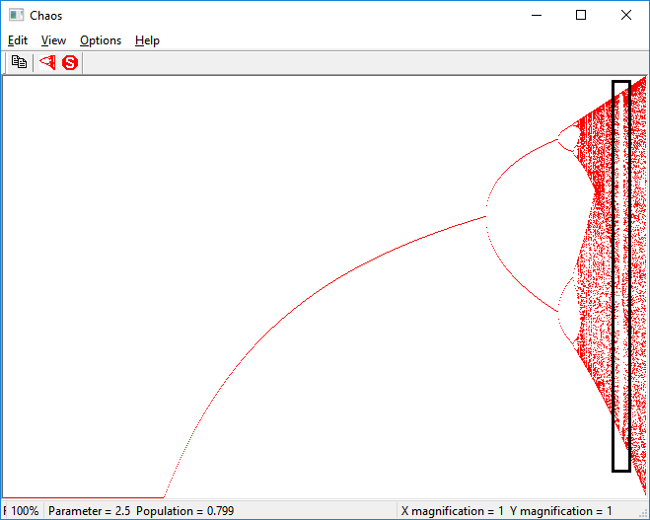

Try zooming in as shown by the rectangle below and you will see that the general character of the entire graph is (inexactly) repeated at all levels of zooming. Just keep zooming in and exploring. At some point you will want to zoom in and explore the chaotic regions, which do have structure to them.

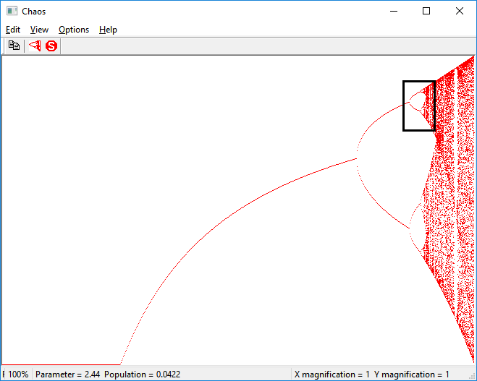

The ɑ (parameter) and y (population) of the current mouse position is displayed in the status bar. Note that the plot is of y (vertical) vs. ɑ (horizontal). The points for any ɑ are drawn after y has been highly iterated. For any ɑ the graph shows the various value(s) of y that the equation cycles through.

One misnomer: The magnification numbers in the lower right are accurate but some may find them to be misleadingly labeled as they are labeled x and y instead of a and y.

Play around with the other controls to see what they do.

If you zoom in enough (a Huge amount) you will hit and surpass the precision limits of floating-point numbers. If this happens, you’ll know it (the program will not crash).

The origin of this equation lies in population studies. The size of generation n+1 depends directly on y (size of the existing population) with the additional factor 1-y to account for too many resources being used by those y individuals. It is interesting that such a simple equation can show such complex, chaotic behavior.

Chaos.exe is freeware and is unsupported.

